Connect with a Child Care Health Consultant (CCHC)
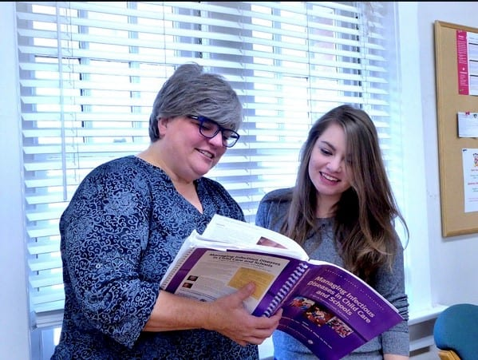
Child care health consultants are health professionals with specialized training in health consultation for early care and education settings. In North Carolina, there are 42 local CCHCs providing comprehensive CCHC support in 32 counties.
During the current pandemic, CCHC services have been temporarily expanded so that COVID-19 specific support is available in every county. To connect with a CCHC, visit the NC Child Care Health and Safety Resource Center’s website: https://healthychildcare.unc.edu/find-a-cchc/
To address issues related to COVID-19, CCHCs:
- Support the implementation of the ChildCareStrongNC Public Health Toolkit including infection prevention and control strategies such as screening, exclusion, sanitation, and social distancing in the classroom
- Provide up-to-date resources and information on prevention and control recommendations from reputable sources
- Communicate with the local health department, environmental health, and child care (licensing) consultants to facilitate coordination and consistent messaging between agencies
- Support the safe inclusion of children with special health care needs
Visit the Administration for Children and Families’ Early Childhood Learning and Knowledge Center for further information on how child care health consultants make early care and educations programs healthier and safer.

